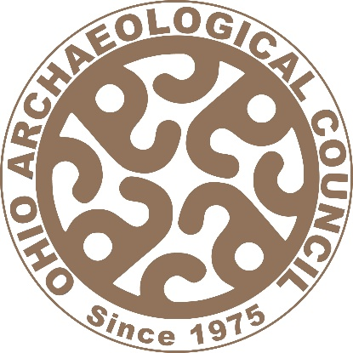
Announcing Ohio Archaeology Month for 2026… Revolutionary Archaeology!
To coordinate with America/Ohio 250 efforts to commemorate Ohio contributions as part of the semiquincentennial and to more broadly relate to celebrating novel approaches, methods, and/or perspectives in addressing old questions.

OAC has received an award of $3000 in grant money from EMH&T to support 2026 Ohio Archaeology Month development efforts. Ways you can participate in and support Ohio Archaeology Month in October are outlined below. Contact POCs David Lamp (lampd@ohio.edu) and Pam Baughman (ohioarch2026@gmail.com) for more info.!
- Poster: A poster will be developed, along with stickers. Print posters and stickers will be distributed at OAC meetings, provided to sponsors, and at event locations. A downloadable copy will also be provided on the website. Design services have been volunteered as a charitable contribution, but CRM companies can provide in-kind support services and/or monetary contributions (an equivalent amount of $250) to add their logo to the poster for sponsorship. Contact David if you are interested in sponsorship or support related to the poster’s development.
- Events: Libraries, Museums, Historical/Archaeological Societies, Colleges/Universities, and Professional Archaeologists/CRM firms are invited to sponsor events such as programs or open houses, develop exhibits or displays, give talks or presentations, provide hands-on experiences, etc. before and during Ohio Archaeology Month in October. Events can be specific to the theme of Revolutionary Archaeology or more broadly about archaeology. A Call for Events form has been created to solicit events information so that a printable and downloadable pdf events brochure can be compiled. This brochure will be posted online to provide a calendar of events associated with Ohio Archaeology Month. Complete the form with your event details and submit through email to Pam at ohioarch2026@gmail.com.
- Student Poster Competition: A Call for Posters is also being distributed to encourage preparation of a conference style poster for presentation to OAC in conjunction with the fall meeting. The poster should be focused on the Revolutionary Archaeology theme and participation is limited to students, with cash prizes and two-year OAC memberships being awarded to the top 3 posters.

